Me llamo ______________________________________________ Hoy es el _______ de ___________

## Spanish I - Term 4 Assessment Review

La ropa y el tiempo – Fill in the appropriate clothing that you would wear in the following weather conditions. Use each clothing only once.

Hace calor

____________________________________________________________________________

____________________________________________________________________________

Hace frío

____________________________________________________________________________

____________________________________________________________________________

Llueve

____________________________________________________________________________

____________________________________________________________________________

Un evento elegante

____________________________________________________________________________

____________________________________________________________________________

Vocabulario: know the following vocabulary words and or phrases.

Hace mal tiempo __________________________________________________

Hace frío ________________________________________________________

Hace fresco ______________________________________________________

Llueve __________________________________________________________

Pasaporte _______________________________________________________

Avión __________________________________________________________

Paisaje _________________________________________________________

Equipaje ________________________________________________________

Playa ___________________________________________________________

Saco fotos _______________________________________________________

Voy en barco _____________________________________________________

Pesco ___________________________________________________________

Hago una maleta __________________________________________________

Botones __________________________________________________________

Huésped _________________________________________________________

Empleado ________________________________________________________

Impermeable _____________________________________________________

Botas __________________________________________________________

Pantalones cortos _________________________________________________

Sombrero _______________________________________________________

Gafas de sol _____________________________________________________

Camisa _________________________________________________________

Suéter __________________________________________________________

Bluejeans __________________________________________________________

Tenis __________________________________________________________

Abrigo __________________________________________________________

Bolsa __________________________________________________________

Traje de baño ___________________________________________________

Falda __________________________________________________________

Cinturón _______________________________________________________

Gorra _________________________________________________________

Ropa interior ___________________________________________________

Calcetines_______________________________________________________

Vestido _________________________________________________________

Blusa ___________________________________________________________

Corbata _________________________________________________________

Almacén _________________________________________________________

Tienda ___________________________________________________________

Mercado __________________________________________________________

Dependiente _______________________________________________________

Mar ______________________________________________________________

Azul ______________________________________________________________

Rosado /a _________________________________________________________

Amarillo /a ________________________________________________________

Rojo /a ___________________________________________________________

Morado /a ________________________________________________________

Verde ____________________________________________________________

Oro ______________________________________________________________

Noun + Adjective Agreement – Colors

¿De qué color es la rosa de Texas?

____________________________________________________________________________

¿De qué colores es la bandera de Canadá?

____________________________________________________________________________

¿De qué color es la casa donde vive el presidente de los EE.UU?

____________________________________________________________________________

¿De qué color son las cebras (zebras)?

____________________________________________________________________________

SER ESTAR

Fill in the use of Ser and Estar

SER ESTAR

|  |  |
| --- | --- |
|  |  |
|  |  |
|  |  |
|  |  |
|  |  |
|  |  |

Fill in the blanks with the appropriate forms of **ser** or **estar**.

1. Tomás y Raúl ______________________ actores.

2. Raúl no ______________________ muy feliz hoy.

3. Tú no ______________________ muy interesante.

4. Tomás ______________________ cómodo.

5. ¿Por qué ______________________ Ud. tan nervioso? Yo ___________________ feliz.

6. Roberto ______________________ mi hermano mayor.

7. El libro ______________________ aquí (here), en la sala de clase.

8. Nosotros ______________________ de España.

Estar + conditions or emotions.

|  |
| --- |
| estar feliz/alegre - |
| estar nervioso/a - |
| estar avergonzado/a - |
| estar equivocado/a - |
| estar enojado/a - |
| estar cerrado/a - |
| estar cansado/a - |
| estar seguro/a |

Direct Object Pronouns

De viaje- The Gómez family is taking a trip to San Juan, Puerto Rico. Underline the direct object then rewrite the sentence using a direct object pronoun.

1. Toda la familia hace las maletas.

____________________________________________________________________________

2. Juan pone el equipaje y la cámara en el automóvil.

____________________________________________________________________________

3. Marcela lleva los pasaportes.

____________________________________________________________________________

4. La abuela, Rosa, busca el periódico.

____________________________________________________________________________

5. Juan tiene los pasajes de avión.

____________________________________________________________________________

6. Marcela está comprando mapas de Puerto Rico.

____________________________________________________________________________

7. La abuela y Marcela visitan los monumentos de San Juan.

____________________________________________________________________________

Answer the following questions:

¿Cuáles son los meses de la primavera?

____________________________________________________________________________

____________________________________________________________________________

¿Qué son las estaciones del año?

____________________________________________________________________________

____________________________________________________________________________

¿Cuáles son los mese del año?

____________________________________________________________________________

____________________________________________________________________________

Present Progressive.

The Present Progressive always has two parts.

1. 2.

Fill in the correct form of estar:

1. Juan _________________ hablando español.

2. Yo _________________ buceando en el mar.

3. Los niños _________________ jugando.

4. Juan y yo _________________ llegando a la fiesta.

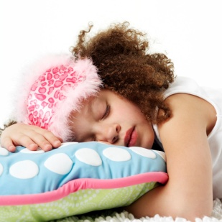Describe each picture using the present progressive.

C:\Documents and Settings\atrakas\Local Settings\Temporary Internet Files\Content.IE5\XO0FIQGW\MC900198598[1].wmfC:\Documents and Settings\atrakas\Local Settings\Temporary Internet Files\Content.IE5\XO0FIQGW\MC900338476[1].wmf

_____________________ _____________________

_____________________ _____________________

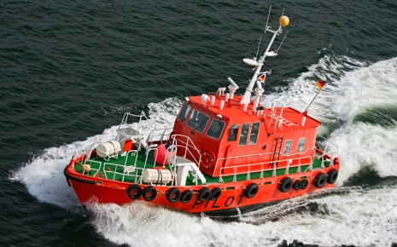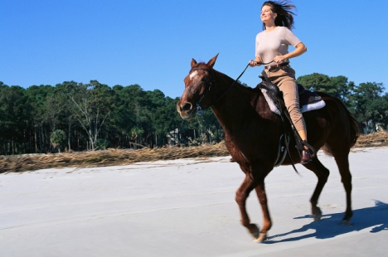

_____________________ ________________________

_____________________ ________________________

Write the present participle of the following regular and irregular verbs.

|  |  |
| --- | --- |
| (dormir) ________________________ | (leer) ________________________ |
| (asistir) ________________________ |  |
|  |  |